Algebra 3-4 Name: _______________________
Factoring Worksheet Block: ______

For problems 1 – 12, factor the expression. If the expression cannot be factored, write not factorable.

1. 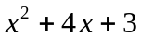 2. 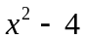 3. 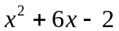

4. 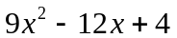 5. 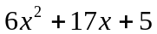 6. 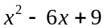

7. 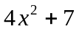 8. 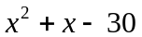 9. 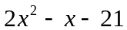

10. 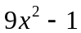 11. 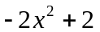 12. 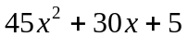

For problems 13 - , solve the equation.

13. (x – 3)(x + 2) = 0 14. (x + 4)(x + 13) = 0 15. 12x² – 3 = 0

16. x² + 4x – 21 = 0 17. x² + 16x + 64 = 0 18. 2x² + 7x – 4 = 0

19. 3x² – 8x + 5 = 0 20. 8x² + 5x – 4 = 2x² – 8x + 1 21. 2x² – x = 21

For problems 22 – 23, find what is needed.
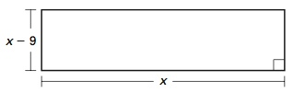
22. Find the dimensions of the figure.
Area of rectangle = 36 square feet

23. You are making a coffee table with a glass top surrounded by a cherry border. The glass is 3 feet by 3 feet. You want the cherry border to be a uniform width. You have 7 square feet of cherry to make the border. What should the width of the border be?
